NEEDED FIXES – 8/2/2018

INTERFACE

New splash

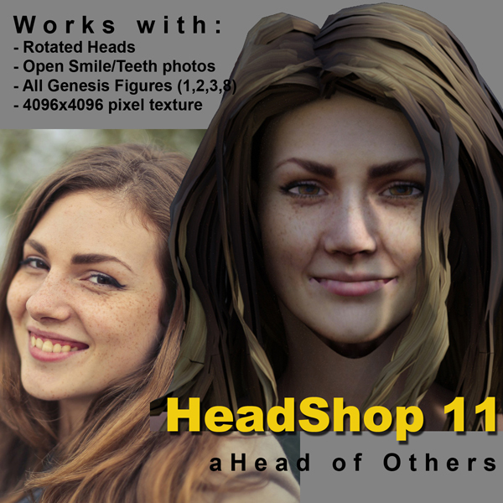

1. Loading page needs to look like this.

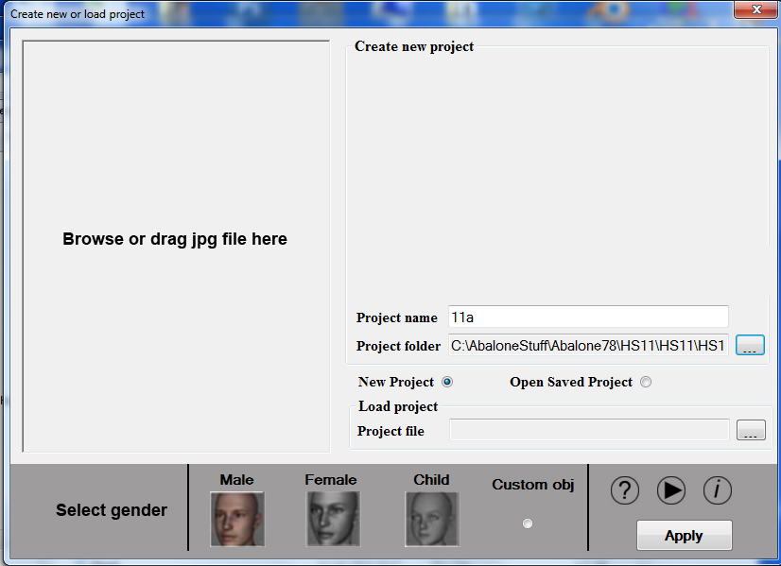

1. Front tab needs to show new smooth slider as shown below 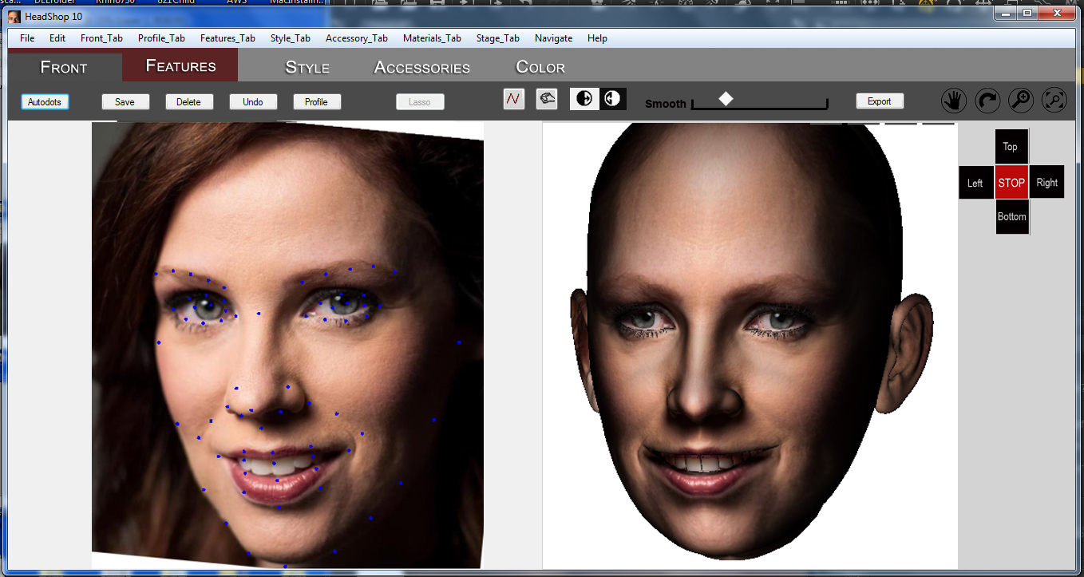

FUNCTIONALITY

1. Autodots not working correctly. (Control points need to light up on both screens. Changes need to be visible after made!) Also, profile, lasso and tools needs to be turned back on). Eyes texture needs to load.

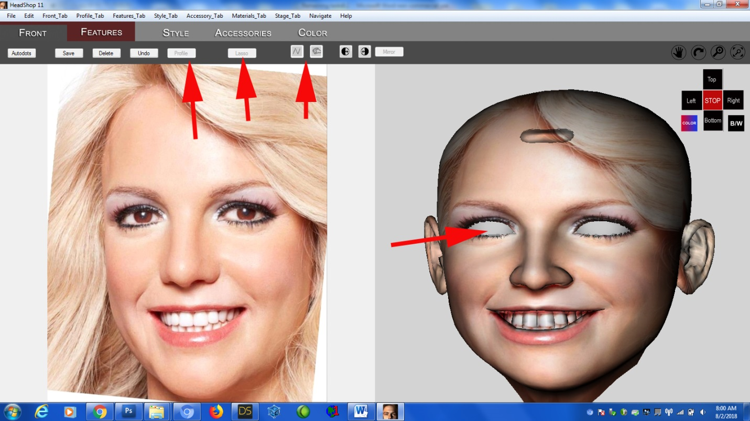



Features tab. When FemWithSmile loaded, “Smile” slider should be set to 100. User can slide slider to “0” to get no smile. Whatever is the setting, export should be exported with the current morph. Also, tongue needs to be deleted.

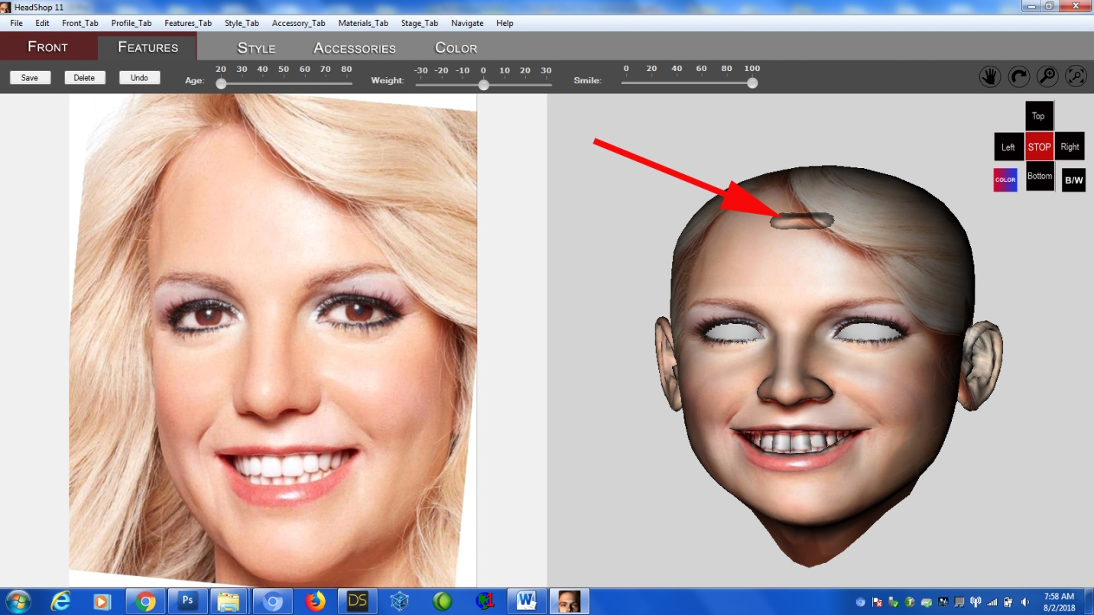

1. Function with slanting heads (needs to be eliminated). Heads should not slant.

This is it.